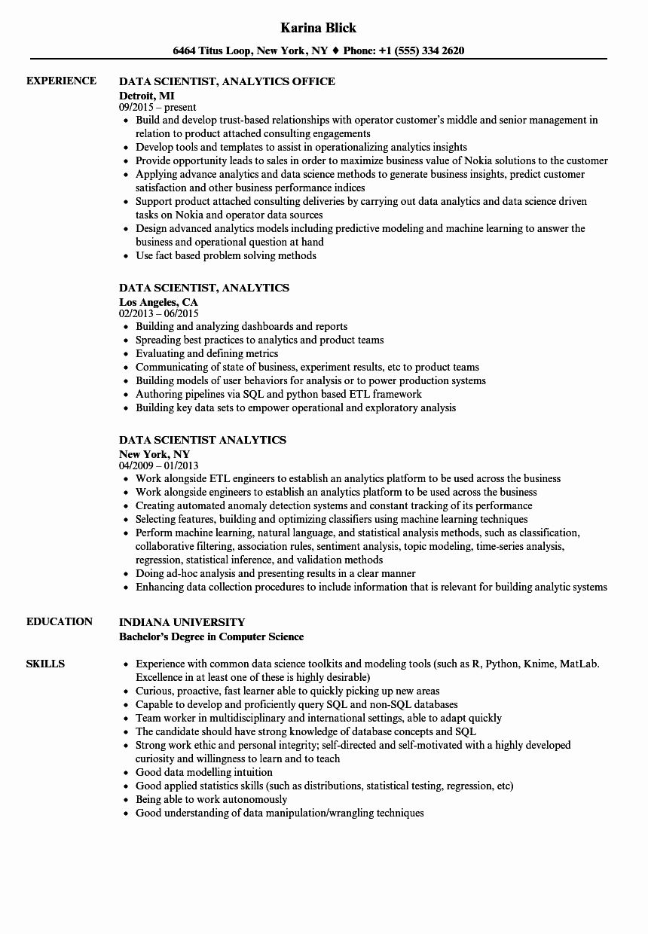
EXPERIENCE
EDUCATION
Karina Blick
6464 Titus Loop, New York, NY♦ Phone: +1 (555) 334 2620
DATA SCIENTIST, ANALYTICS OFFICE
Detroit, MI
09/2015-present
• Build and develop trust-based relationships with operator customer's middle and senior management in relation to product attached consulting engagements
• Develop tools and templates to assist in operationalizing analytics insights
• Provide opportunity leads to sales in order to maximize business value of Nokia solutions to the customer • Applying advance analytics and data science methods to generate business insights, predict customer satisfaction and other business performance indices
• Support product attached consulting deliveries by carrying out data analytics and data science driven tasks on Nokia and operator data sources
• Design advanced analytics models including predictive modeling and machine learning to answer the business and operational question at hand
• Use fact based problem solving methods
DATA SCIENTIST, ANALYTICS
Los Angeles, CA
02/2013 - 06/2015
⚫ Building and analyzing dashboards and reports
• Spreading best practices to analytics and product teams
⚫ Evaluating and defining metrics
• Communicating of state of business, experiment results, etc to product teams
• Building models of user behaviors for analysis or to power production systems
• Authoring pipelines via SQL and python based ETL framework
⚫ Building key data sets to empower operational and exploratory analysis
DATA SCIENTIST ANALYTICS
New York, NY
04/2009 - 01/2013
• Work alongside ETL engineers to establish an analytics platform to be used across the business
• Work alongside engineers to establish an analytics platform to be used across the business
• Creating automated anomaly detection systems and constant tracking of its performance
⚫ Selecting features, building and optimizing classifiers using machine learning techniques
• Perform machine learning, natural language, and statistical analysis methods, such as classification, collaborative filtering, association rules, sentiment analysis, topic modeling, time-series analysis, regression, statistical inference, and validation methods
⚫ Doing ad-hoc analysis and presenting results in a clear manner
• Enhancing data collection procedures to include information that is relevant for building analytic systems
SKILLS
INDIANA UNIVERSITY
Bachelor's Degree in Computer Science
• Experience with common data science toolkits and modeling tools (such as R, Python, Knime, MatLab. Excellence in at least one of these is highly desirable)
• Curious, proactive, fast learner able to quickly picking up new areas
⚫ Capable to develop and proficiently query SQL and non-SQL databases
⚫ Team worker in multidisciplinary and international settings, able to adapt quickly
• The candidate should have strong knowledge of database concepts and SQL
• Strong work ethic and personal integrity; self-directed and self-motivated with a highly developed curiosity and willingness to learn and to teach
• Good data modelling intuition
• Good applied statistics skills (such as distributions, statistical testing, regression, etc)
• Being able to work autonomously
• Good understanding of data manipulation/wrangling techniques

